ADDITIONAL RESOURCES
ADVANCED CARE PLANNING
Thoughtful Life Conversations strives to empower Arizonans to make known their life wishes and care directives, and to have thoughtful life conversations that result in honored healthcare wishes/goals and improved care towards end of life. VICaP has advance directive Life Care Planning Packets available upon request and can assist with completing the forms. For more information, call Thoughtful Life Conversations at 602-445-4312, or the VICaP office at 520-459-8146.
For assistance with filling out the forms, call Thrive Wellness Center to schedule an appointment. Thrive Wellness Center: (520) 263-3293.
HOUSECLEANING SERVICES
If you need housecleaning services:
Sandy O’Neal  Sparrow’s Helping Hands | 520-678-1651  Also assists with errands, shopping, laundry, house-sitting, meal prep, etc.
Senior Care Cleaning Services  Provided by Sierra Vista Clean | 520-378-5173  (Sierra Vista & Hereford residents)
Victoria  Christian Housecleaning Srvcs. | 520-456-4133
Felicia’s Crystal Clean | 520-271-6746  Also assists with errands, shopping, laundry, etc.
Teri Baxter  Mrs. B’s Cleaning | 352-874-9621
HOME HEALTH SERVICES
If you need home health/caregiver services:
Luminaria Home Care  520-459-8073 | Legacy Health Care  520-335-6118
Bayada Home Health  520-459-4800 | BrightStar Care  520-335-6680
Josie, Independent Certified Caregiver  520-227-3025 | Trinity Visiting Nurse & Home Health Care 520-458-1536
OVER
INTERCITY TRANSPORTATION WITHIN COCHISE COUNTY
The City of Douglas and SouthEastern Arizona Governments Organization (SEAGO) have partnered to create a long-awaited intercity bus service (Cochise Connection) linking the cities of Douglas, Bisbee, Palominas/Hereford and Sierra Vista. This low-cost, fixed-route bus service links with city bus systems in Douglas, Bisbee and Sierra Vista, and runs at several times throughout the day both north-bound and south-bound. For more information, call the City of Douglas at 520-417-7300.
STATE HEALTH INSURANCE ASSISTANCE PROGRAMS/MEDICARE
If you have questions concerning Medicare or the State Health Insurance Plans (SHIP), SEAGO Area Agency on Aging (AAA) provides assistance. Call Ramona MacMurtrie, the Medicare/Health Insurance Coordinator, at 520-432-2528, ext. 222, or email shiphelp@seago.org.
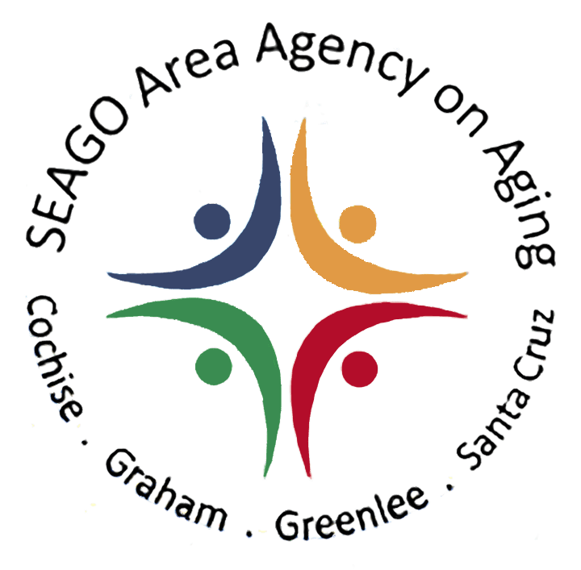
COCHISE COUNTY AT-RISK REGISTRATION
This program is designed for anyone who may need assistance during an emergency evacuation or for anyone who would require special medical considerations during an emergency. Once registered, first responders will be better equipped to assist you during these events.
Visit https://www.cochise.az.gov/health-and-social-services/risk-registration to register online, or call the VICaP office at (520) 459-8146 to request a paper copy of the registration forms.
For additional resources or questions, please call the VICaP office at 520-459-8146. If the service is not provided by VICaP, we may still be able to provide references to other organization or resources.

